Mission
The Mission of St. Joseph’s/Candler is “Rooted in God’s love, we treat illness and promote wellness for all people.” Our organizational vision is “To set the standards of excellence in the delivery of healthcare throughout the regions we serve. We are led by our values of:” Compassion, Quality, Integrity, Courtesy, Accountability and Teamwork.
The six Health System values are represented by the six brush strokes of the logo preceding the St. Joseph’s/Candler name. This serves as a constant reminder, not only to our coworkers and physicians, but to the community at large that our values precede-literally and figuratively-everything we do as a Health system and Healthcare provider.

Community Benefits
St. Joseph’s/Candler (SJ/C) is a private, non-profit 501-3 organization as designated by the Internal Revenue Services. The Health System’s charitable mission, “Rooted in God’s Love, we treat illness and promote wellness for all people,” compels our System to provide services, programs and outreach to people regardless of their ability to pay. These efforts are especially concentrated on the poor and marginalized people in Chatham and surrounding counties. Among the System’s traditional efforts to provide charity care and financial assistance to people in the most need, programs and services are provided outside the walls of both hospitals taking needed services directly to people in their own communities. Four (4) flagship outreach efforts of the System include St. Mary Community Center, the African American Health Information & Resource Center and two free clinics; St. Mary’s Health Center and the Good Samaritan Clinic. These efforts address the socio-economic determinants of health including programs in education, workforce development, advocacy and safe-affordable housing, as well as, provide traditional primary health care services for the uninsured aged 19-64. These programs are recognized nationally and regionally as best practices. Coupled with other System programs such as mobile health services, cancer outreach, health education lectures and many other programs provide the most comprehensive approach to ensure SJ/C’s charitable mission is carried out throughout the System and in the community. In fiscal year 2017, SJ/C documented more than $81.9m in total community assistance.

Bioethics
Because "ethics is at the heart of what we do as a ministry of healing," it should be a foundation for good care, and done very well (CHA, 2013 Ethics Excellence). The ethics service at SJC includes 24/7 consultation service to support and advise physicians, staff and family when complex inpatient and outpatient issues arise. The Ethics Board includes an interdisciplinary team of physicians, nurses, administrators, pastoral care, social services and community liaisons. A subcommittee of this board, chaired by the Director of Clinical Ethics, Dr. Kathleen Benton, DrPH answers every consultation with immediate review. Ethics also offers community education and clinician advisement on areas including advance directives, POLST (Physician Orders for Life-sustaining Treatment), quality of life and dignity during disease. The Ethical and Religious Directives for care (ERDs) help to shape the ethical process and provide guidance for good care. Please contact Kathleen Benton (912-667-7527) at any time with further information.

Link to Ethical and Religious Directives for Care
http://usccb.org/issues-and-action/human-life-and-dignity/health-care/upload/Ethical-Religious-Directives-Catholic-Health-Care-Services-fifth-edition-2009.pdf
Link to PHYSICIAN ORDERS FOR LIFE- SUSTAINING TREATMENT (POLST) form
This is a Physician Order guided by the patient’s medical condition and based upon personal preferences
verbalized to the Physician or expressed in an Advance Directive.
http://intranet/formsrepository/POLST/POLST_20130223.pdf

Pastoral Care
Spiritual Care in the Clinical Setting
Christina M. Puchalski, M.D.
Assistant Professor, Department of Medicine and Health Care Sciences
Director, The George Washington Institute for Spirituality and Health (Gwish)
The George Washington University
Spirituality, broadly deigned as that which gives a transcendent meaning to life, is central to the human experience and is often the dominant issue for patients dealing with chronic illness and end of life. As people deal with situations such as illness and life stress which challenge them and their definition of themselves, spiritual questions arise. People begin to question their purpose and meaning in life.
Healing involves the restoration of wholeness which may be manifested by a transcendent set of meaningful experiences which may help a person accept their situation and find meaning in the midst of suffering. Surveys show patients want to discuss their spiritual concerns with their physicians. Studies indicate spirituality is helpful for people coping with serious illness. Over 65 medical schools in the U.S. teach courses on spirituality and medicine. The Association of Medical Colleges supports the development of these courses in recognition of the importance of respecting patients’ religion and spirituality in the delivery of health care. These courses teach physicians and other healthcare professionals how to do a spiritual assessment and how to utilize patient spirituality in the clinical setting. Key elements of spiritual care include the act of listening to patients’ fears and hopes, the practice of compassionate presence and the recognition of spiritual experiences which can help patients as they deal with suffering and stress. The demonstrated benefits of spirituality as well as the recognition of the importance of treating the whole patient, body, mind, and spirit, demonstrates the need for integration of spirituality and medicine.

The following tool may assist you in your assessment of your patient.
Spiritual Assessment Tool
An acronym that can be used to remember what is asked in a spiritual history is:
F: Faith or Beliefs
I: Importance and Influence
C: Community
A: Address
Some specific questions you can use to discuss these issues are:
F: What is your faith or belief?
Do you consider yourself spiritual or religious?
What things do you believe in that give meaning to your life?
I: Is it important in your life?
What influence does it have on how you take care of yourself?
How have your beliefs influenced your behavior during this illness?
What role do your beliefs play in regaining your health?
C: Are you part of a spiritual or religious community?
Is this of support to you and how?
Is there a person/group of people you really love or who are really important to you?
A: How would you like me, your healthcare provider, to address these issues in your healthcare?

General recommendations when taking a spiritual history:
1. Consider spirituality as a potentially important component of every patient’s physical well being and mental health.
2. Address spirituality at each complete physical examination and continue addressing it at follow-up visits if appropriate. In patient care, spirituality is an ongoing issue.
3. Respect a patient’s privacy regarding spiritual beliefs; don’t impose your beliefs on others.
4. Make referrals to chaplains, spiritual directors, or community resources as appropriate.
5. Be aware that your own spiritual beliefs will help you personally and will overflow in your encounters with those for whom you care to make the doctor-patient encounter a more humanistic one.
1999 Christina Puchalski, M.D. Reprinted with permission from Christina Puchalski, M.D.

St. Joseph’s/Candler has pastoral care team that is here to help with spiritual and emotional resources that can help your patient toward recovery and a more fulfilling personal life. They are available for consultation or pastoral counseling by contacting their office. St. Joseph’s- 819-2129 Candler 819-6001

Palliative Care
and the Role of the Chaplain

- Specialized medical care for persons with serious or life threatening illness.
- Primary goal: ease symptom burden and promote quality of life.
- Uses an interdisciplinary team approach to address the needs of patients and their families in collaboration with the patient’s own doctors.
- Integrates the physical, spiritual, and psychological aspects of patient care.
- Is applicable early in the course of a serious illness, in conjunction with other therapies that are curative or intended to prolong life such as chemotherapy or radiation.

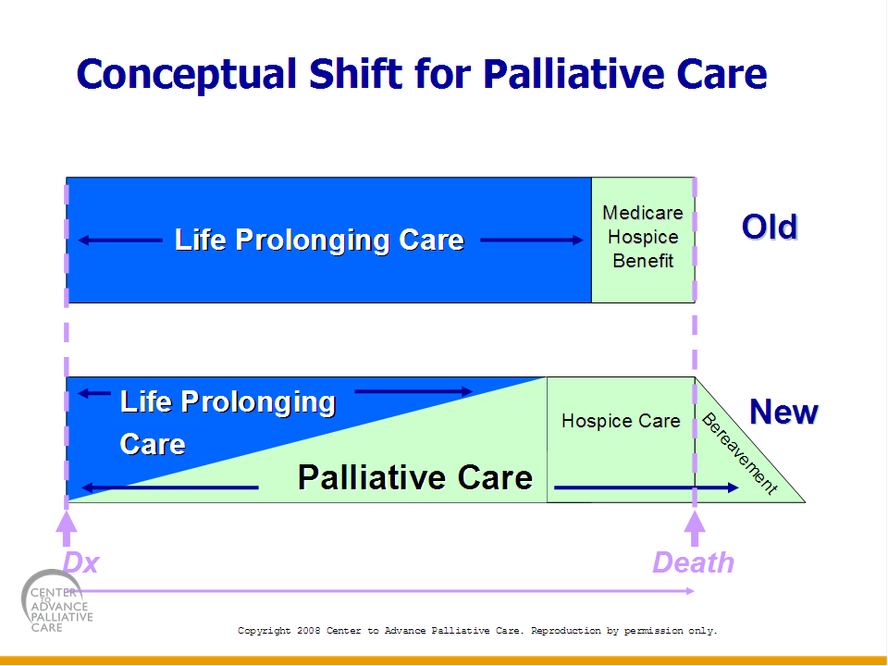

- A physician order for a Palliative Care Consult should be considered when a patient is diagnosed with any serious illness such as cancer, end stage renal, cardiac, liver or pulmonary disease, and is also struggling to manage difficult symptoms such as pain, nausea and vomiting, loss of appetite, shortness of breath, fatigue, difficulty sleeping, anxiety or depression .
- The Palliative Care program at SJCHS, is provided in collaboration with The Steward Center for Palliative Care. The Interdisciplinary Team consists of: board certified Physicians, Certified Nurse Practitioners, Nurses, Social Workers, Dieticians, a Life Coach and a Chaplain, both in an In-Patient hospital setting, and in the Out-Patient Clinic at the Lewis Cancer and Research Pavilion.
Role of the Chaplain in Palliative Care
- Companion in hope, who seeks to provide a ministry of care to persons of all faith traditions, focusing specifically on those struggling with life threatening or serious illnesses.
- Scriptural basis:
  - Isaiah 40:1….. “Comfort, give comfort to my people…speak tenderly…”
  - Psalm 23…. “Like a shepherd he feeds his flock…..”
We are called to the same shepherding…to engage in reviving people’s spirits….tend their wounds (physical or emotional), and lead them to refreshing waters.
- Pastoral/Spiritual Care seeks to:
  - Heal, nurture, sustain, guide, reconcile, liberate, and empower an individual in the midst of illness.
Lartey, E. (2003). In living color: An intercultural approach to pastoral care and counseling.
Philadelphia: Jessica Kingsley Publishers.
- Role of the Chaplain in Palliative Care:
  - Tend the entire person, Body, Mind and Spirit.
  - Incorporate the physical, social, psychological, and spiritual aspects of the person seeking care.
  - Provide a sacred ministry of presence and grace, framed by the postures hospitality and reverence.

- Pastoral/Spiritual Care is INTEGRAL to the Mission of Mercy here at St. Joseph/Candler Hospital
Please contact the Palliative Care team for assistance. Candler 819-8927 St. Joseph’s 819-3374
Medical Clinics/Outreach
Providing treatment for disease and illness is only one facet of St. Joseph's/Candler's role in the community. Our outreach initiatives also provide a positive force in the overall health and well-being of the areas we serve.
We take a holistic approach to healing. We believe that external factors are essential to good health, including safe and adequate housing, education, access to information and meaningful employment.
Our mission of promoting wellness for all people incorporates this approach and can be seen in our numerous community outreach efforts.
St. Mary’s Community Center- St. Mary's Community Center is a community outreach initiative of St. Joseph's/Candler and a living demonstration of its mission. The center is located in the Cuyler-Brownsville neighborhood, a struggling African-American community with a rich history and strong community spirit.
Located at 812 W. 36th St. Savannah, Ga. 31415 912-447-0578
The Center serves many individuals and families from Savannah's poorest census tracts. The injustices of poverty are many- unemployment, illiteracy, lack of health care, substandard housing, drugs and crime. The center strives to accompany people to improve their quality of life. A free Eye clinic is offer in conjunction with the Lyons Club where patients receive eye exams and glasses.
St, Mary’s Health Center- St. Mary's treats people who fall into the uncomfortable space between not having insurance and not qualifying for Medicaid. We give them a medical home where SJ/C physicians volunteer their time and the nurses work to find affordable or free medications. Located at 1302 Drayton Street Primary care for uninsured adults ages 19-64 who don't qualify for Medicaid , Non-emergency care ,Hours: Monday through Friday, from 8:30 a.m. - 3:30 p.m. . Call 912 4439409 for more information or to have your patient make an appointment
The Good Samaritan Clinic- In response to the lack of a healthcare access point on the West side of Chatham County, the GSC opened in 2007. If your patient needs a medical home and meets the following criteria : Over the age of 18, No Health Insurance, Household income that does not exceed stated guidelines.. Located at St. Joseph's/Candler Medical Plaza 4704 Augusta Road Garden City, GA 31408 they can be reached at 912) 964-4326 to schedule an appointment.
The African American Health and Information Resource Center- The St. Joseph's/Candler's African-American Community Health Initiative seeks to partner with community groups/organizations to reduce the incidence of health conditions that adversely affect African-Americans by utilizing education, screenings and networking by community citizens on a grass-roots level. The center is located at 1910 Abercorn Street Savannah, GA 31401 and can be reached at (912) 447-6605.

