Nurse Practitioner and Physician Assistant
Medical Transcription Dictation Instructions

DICTATION LINE: 819-6560

On answer you will hear voice prompts
- Enter your 4-digit number
- Choose campus for patient location; 1 for St. Joseph’s; 2 for Candler
- Enter report type by number
1 History and Physical
3 Discharge Summary
4 Consultation Note
- Enter 9-digit medical record number
- At “Begin Dictation” prompt please state:
- Your name
- PHYSICIAN’S name you are dictating for
- Patient‘s name
- Medical record or DOB
- Date of admission/service
- “Send a copy to Dr. _____” (physician co-signer)
- When dictation is complete press 9 or hang up
(press “9” and then “1” for the document number)

IN MEDITECH:
- Review and edit the report
- Assign to the physician for co-signature (Edit Other Signers)
- Next Screen
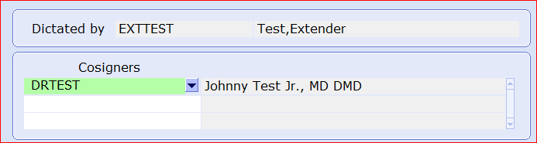
- Sign your report after you have assigned for co-signature

For successful dictation in the Medical Transcription Dictation System:
- Avoid cell phone usage (missed dictation if reception interference and dropped calls).
- Avoid extremely low voice volume (difficult capture by the dictation speech engine).

For dictation assistance call 819-6088
For assistance with your dictate number call 819-6091
February 2019

